**1.  Introduction**

PIXNEP is an online clothing website which will allow customers to find the right product from the comfort of their homes. The main focus of our web application is to allow customers to find the right product just with a few clicks. Users of the system are allowed to register themselves and can create their profile. The system is designed to allow the users to take the customization into their own hands and upload their designs into the selected products without prior knowledge of complex applications. It is meant to be user-friendly and provide a convenient user experience.

R. Vaidya [1] mentions that, the popularity of online shopping among Nepalese customers has increased with the cost-reduction of technology-based goods, the cost of internet services, and easy access to the internet. At the same time, the convenient modes of payments, and user-friendly, as well as, interactive shopping apps are further paving a pathway to unprecedented growth in the online shopping companies. The paper has taken 300 respondents, as a sample, who have at least twice shopping experiences, from a single online shopping company. Arthur, James [3] says concerning the factors that influence or hinder online shopping, Ernst and Young (2000) reported that Internet users purchased online because of good product selection, competitive prices, and ease of use, but were concerned about shipping costs, lack of opportunity to prior examining the products, as well as, the confidentiality of credit card and personal information. Know and Lee (2003) explored consumers’ concerns about payment security and its relationship to online shopping attitudes and actual purchases.

It is to be noted that this system will contain some unique features which will not be found in any other websites in Nepal. So, this website will introduce these new features to the Nepalese market.

**2. Problem Statement**

Sometimes when we look at shopping websites like Daraz, Sastodeal, Hamrobazar the users of that website are limited to the designs they would like to wear. If a person has their eyes on a specific design on Pinterest they may want to wear it but we can't always seem to find the right piece of clothing. This can limit the user into buying an unsatisfactory product.

The next problem that occurs in the context of Nepal is too much western influence on our culture. As we are aware Nepal is a diverse country with different cultures. Despite that, we seem to be highly influenced by the western cultures. There are many great designers and underrated artists in our country too. So, our website can become a bridge for them to showcase their art to the whole Nepalese as well as international communities.

According to Barron, Anne [7], The law's categories are best understood in their singularity: as products of values that are peculiar to the legal system; a history that is peculiar to the copyright system; and a logic of property that is simply not reducible to the logic of aesthetic judgment. R. Vaidya [4] tells in context to Nepal that time-saving, offers, easy ordering system and information available at the online shopping portal, were the main reasons for the shoppers to prefer online shopping. The service quality provided by the online company, made the Nepalese customer, prefer online shopping. The quality of the product delivered to the customer was seen to be the major problem in Nepalese online shopping. The delivery of the wrong product was also seen as one of the problems in online shopping in Nepal.

In conclusion, many online clothing websites have to face the following difficulties:

1. Unavailability of desired products limit people from expressing how they feel.
2. A poorly designed website that is difficult to navigate can lead to customer frustration and a loss of sales.
3. Technical issues can arise during development, such as server downtime, slow loading times, and compatibility issues with different browsers and devices.
4. Poor customer Service
5. Western culture influence

**3. Objectives**

PIXNEP is designed to be a people's website. Complexity is the last thing that our website needs. To put it another way, we want our website to be user-friendly so that people of any generation/age can be familiar with the design and working of our site.

Some of the common objectives of our website are as follows:

1. To provide users the opportunities to choose their own design.
2. To offer excellent customer service and support to enhance customer satisfaction.
3. To encourage artists and designers in general and provide a reliable platform for them to showcase their artworks.
4. To create a user-friendly and intuitive website experience.

**4. Methodology**

This project is our first project so we are going to use Agile method since agile method allows us to make frequent changes to the app. This project does not have a specific set of requirements so we will use the Agile method. ‌Coram, M., and S. Bohner. [5] says while some organizations affirm that agile methods solve all their problems, few have shown consistent success over a range of typical software projects. Agile methods have advantages, especially in accommodating change due to volatile requirements.

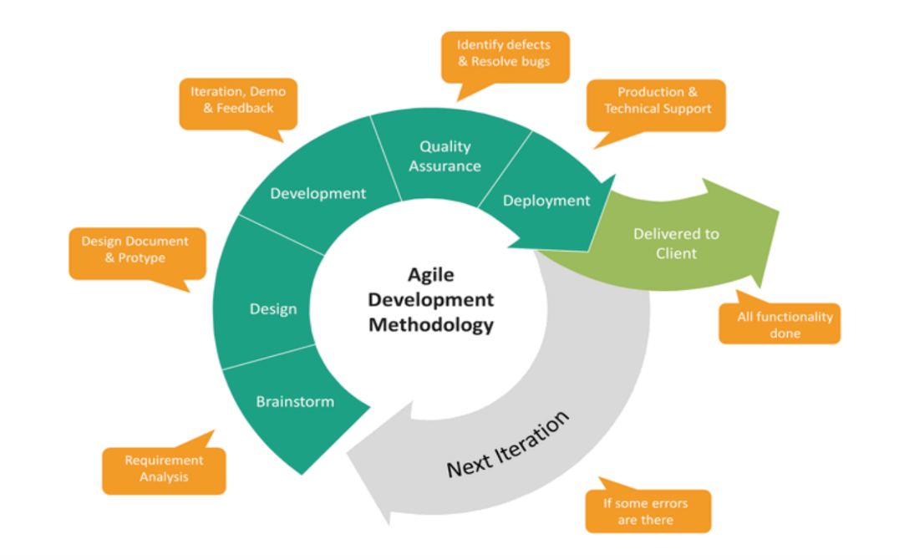

**Figure 4.1 Agile Methodology**

**4.1 Requirement identification:**

Before diving into the development of the system, we need to identify the requirements of our system to act on the client’s needs. Requirement identification allows us to determine what is included in the project and what is excluded. This helps to reduce scope creep. To do this we need to take a thorough look into the existing systems to understand what services they provide and which services they are missing. The study of the existing system is done below:

**4.1.1 Study of Existing system:**

Sunitha, C., and M. Gnanadhas.  [2] ‌ thinks that the largest factor preventing more people from shopping online is the “trust factor”. The fear that online merchants will cheat, lose the credit information, or use personal information will invade their personal privacy, etc. Secondary factors can be summarized as “hassle factors” like shipping costs, returns, and inability to touch and feel the products before purchase

For this study, we will be looking at a site called thulo.com.

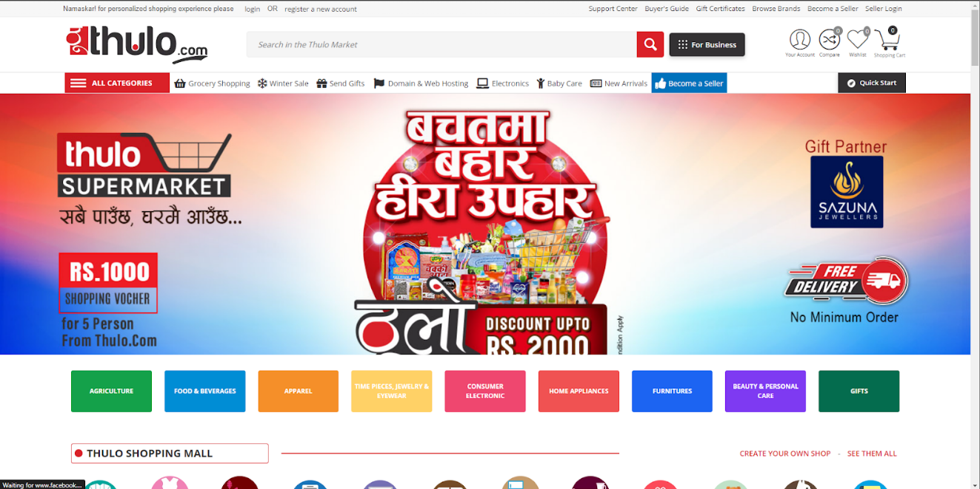**Figure 4.2 Home Page**

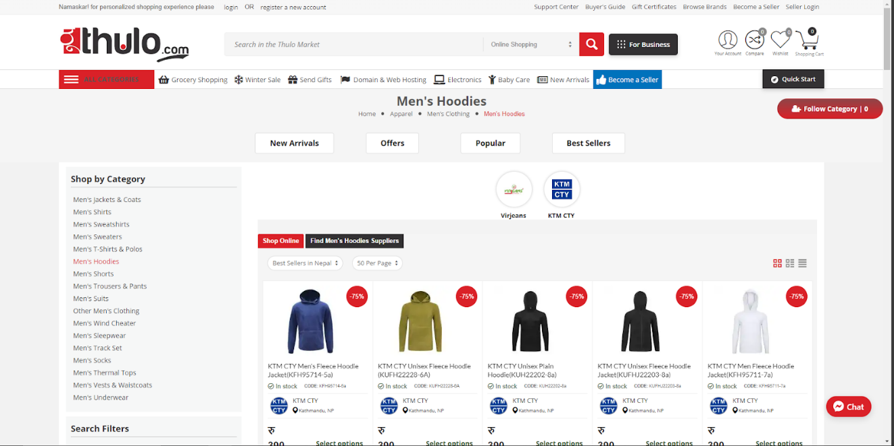

**Figure 4.3 Hoodie selection**

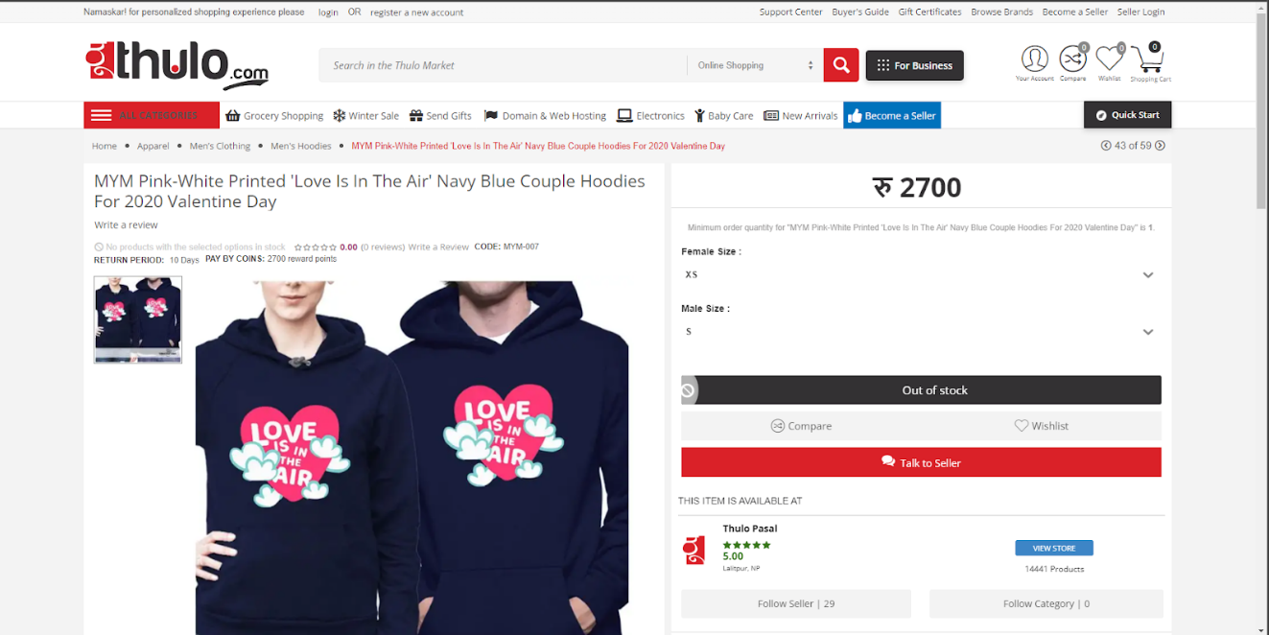

**Figure 4.4 product page**

Some good comments for thulo.com website are as follows:

1. Faster loading times
2. Increased accessibility
3. Good SEO

Some bad comments for that website are:

1. Complex and Overwhelming
2. Reduced customer service
3. Security concerns

**4.1.2 Requirement collection**

Hussain, Azham, and Emmanuel O. C. Mkpojiogu. [6] Requirement engineering is at the foundation of every successful software project. There are many reasons for software project failures; however, poorly engineered requirements process contributes immensely to the reason why software projects fail. Software project failure is usually costly and risky and could also be life threatening. Projects that undermine requirements engineering suffer or are likely to suffer from failures, challenges and other attending risks.

Any process of the requirements is divided into two parts:

**Functional Requirements:**

The functional requirements include user input, the processing and the output. The functional requirements of JUJU are as follows:

1. User Registration and login
2. Product catalog and search
3. Shopping cart and checkout
4. Payment process
5. Content management
6. Mobile optimization
7. Place to select and upload the designs
8. Order management

**Non-Functional Requirements:**

Non-functional requirements describe how a system should behave in terms of performance, security, usability, reliability, scalability, maintainability, and other characteristics.

1. Maintainability
2. Scalability
3. Compatibility
4. Branding and design
5. Copyright law and the claims of art

**4.2 Feasibility Study**

Feasibility Study assesses the operational, technical and economic merits of the proposed project. The feasibility study is intended to be a preliminary review of the facts to see if it is worthy of proceeding to the analysis phase. The primary objective of a feasibility study is to determine whether the proposed project is technically feasible, economically viable, and financially feasible. It helps to identify potential risks, challenges, and opportunities associated with the project and provides a basis for decision-making. A proper feasibility study is essential for probable achievement

**4.2.1 Economic Feasibility:**

The economic feasibility determines the cost that is required to continue this project. It is related to the ROI (Return on Investment). It determines whether the project is worth it or not. To determine economic feasibility, a cost-benefit analysis is typically conducted. This analysis considers all the costs associated with the project, including direct costs such as labor and materials, as well as indirect costs such as administrative and overhead costs.

**4.2.2 Technical Feasibility:**

The technical feasibility includes the technical requirements of the system. Any system that is built should not have complex technical components. The technical aspect must be as simple as possible. In order to develop this software, we use software resources that other websites used to build their software products. It is an evaluation of the technical aspects of a project to determine if it can be developed, implemented, and maintained using the available resources.

**4.2.3 Operational Feasibility:**

Operational feasibility is an assessment whether the proposed system is capable of being implemented or not. It depends on the practicality and suitability of the software. It means whether the proposed software is easy to use and implement or hard. The operational feasibility can be achieved by a simpler UI/UX design.

**4.3 High Level Design of System:**

The goal of HLD is to create a blueprint for the system that can guide the development process and ensure that the final product meets the desired requirements. The HLD process typically includes identifying the system's goals and requirements, defining the major components and their relationships, and specifying the interfaces between components. A well-designed HLD should provide a clear understanding of how the system will work, how its various components will interact, and how it will meet its performance, scalability, and maintainability goals. It should also consider potential risks and contingencies, such as failure modes and disaster recovery.4.3.1 Data Flow Diagram (DFD):

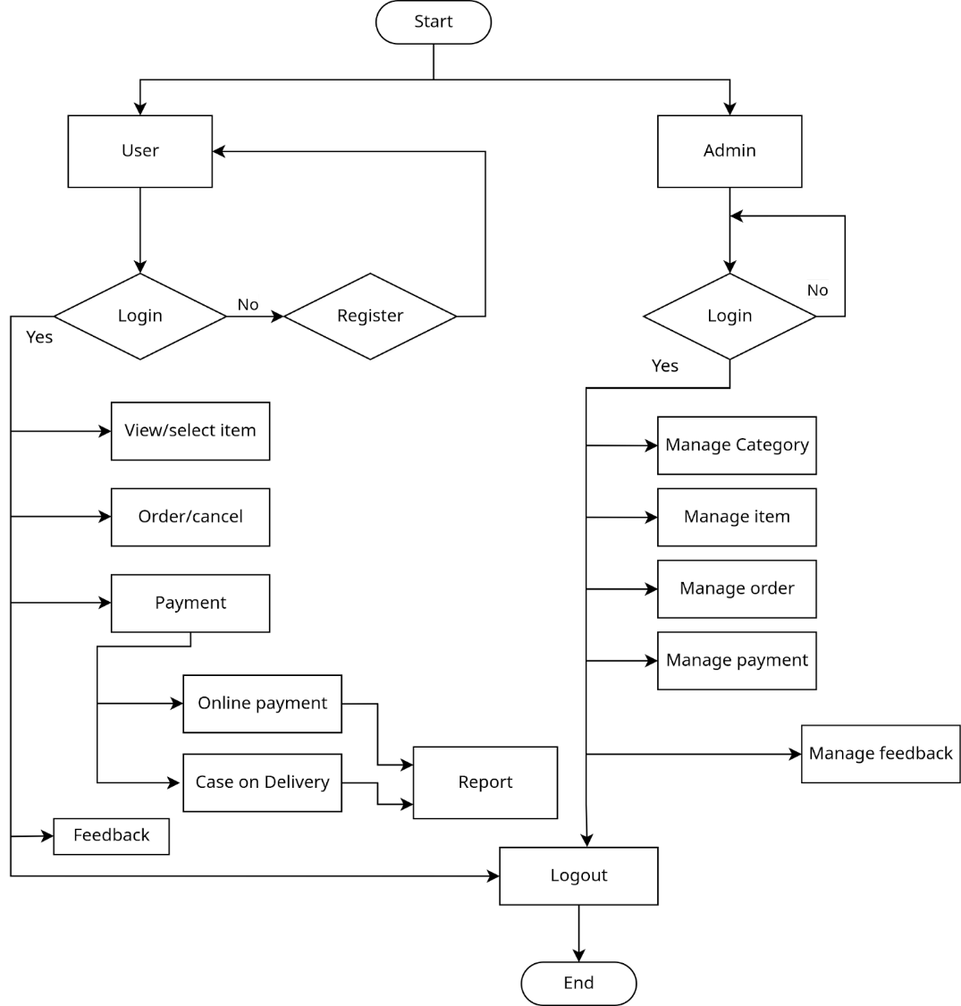

**Figure 4.5 Data Flow Diagram**

**5. Gantt Chart:**

|  |  |  |  |
| --- | --- | --- | --- |
| Task | Start Date | End Date | Duration |
| Feasibility Study | 2023-03-26 | 2023-03-29 | 3 days |
| Requirement Analysis | 2023-03-29 | 2023-04-05 | 7 days |
| Planning | 2023-04-05 | 2023-04-15 | 10 days |
| Design | 2023-04-15 | 2023-04-29 | 14 days |
| Implementation | 2023-04-29 | 2023-07-17 | 79 days |
| Testing | 2023-07-17 | 2023-07-24 | 7 days |
| Documentation | 2023-03-26 | 2023-07-24 | 120 days |
| Maintenance | 2023-07-24 | - | Onwards |

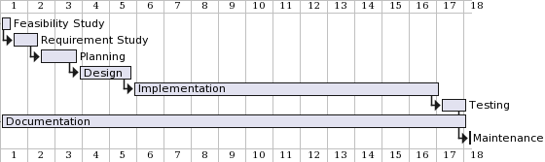

**Figure 5.1 Gantt chart**

**6. Expected outcomes:**

At the completion of this website project, users will be able to choose a specific design or upload their own designs easily to desired products i.e. wearable items. They will be able to find the right product without the cost of traveling far distances and from the comfort of their own homes.

**7.  References**

[1] R. Vaidya, “Online Shopping in Nepal: Preferences and Problems,” Journal of Nepalese Business Studies, vol. 12, no. 1, pp. 71–86, Dec. 2019, doi: https://doi.org/10.3126/jnbs.v12i1.28184.

[2] ‌ Sunitha, C., and M. Gnanadhas. “Problems towards Online Shopping.” International Journal of Emerging Technologies in Engineering Research (IJETER), vol. 6, no. 1, 2018, www.ijeter.everscience.org/Manuscripts/Volume-6/Special%20Issue-1/Vol-6-special-issue-1-M-04.pdf.

[3] ‌Arthur, James. “Communications of the IBIMA.” IBIMA Publishing, 23 Feb. 2015, www.ibimapublishing.com/journals/CIBIMA/cibima.html

[4] R. Vaidya, “Online Shopping in Nepal: Preferences and Problems,” Journal of Nepalese Business Studies, vol. 12, no. 1, pp. 71–86, Dec. 2019, doi: https://doi.org/10.3126/jnbs.v12i1.28184.

[5] ‌Coram, M., and S. Bohner. “The Impact of Agile Methods on Software Project Management.” 12th IEEE International Conference and Workshops on the Engineering of Computer-Based Systems (ECBS’05), vol. 1, no. 23, 2019, doi: https://doi.org/10.1109/ecbs.2005.68.

[6] Hussain, Azham, and Emmanuel O. C. Mkpojiogu. “Requirements: Towards an Understanding on Why Software Projects Fail.” Requirement Determination, vol. 2, no. 4, 2016, doi: https://doi.org/10.1063/1.4960886.

[7] Barron, Anne. “Copyright Law and the Claims of Art.” Papers.ssrn.com, 4 Jan. 2020, papers.ssrn.com/sol3/papers.cfm?abstract_id=346361.